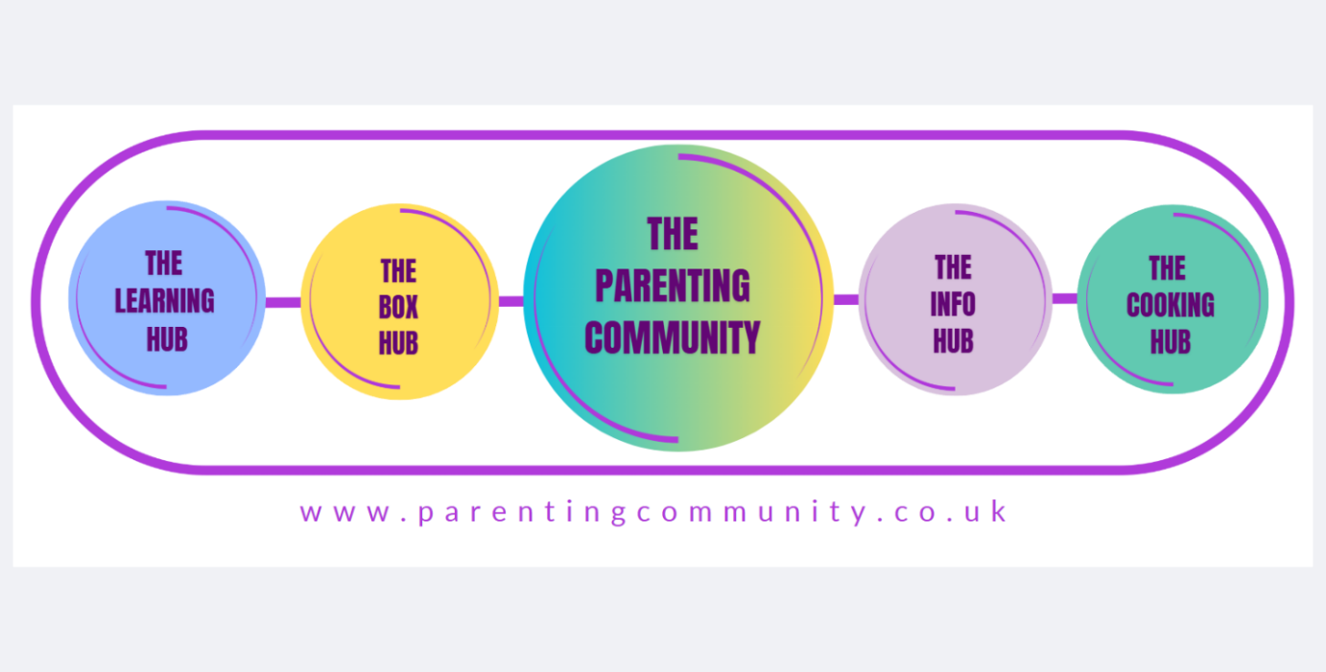

Refund Policy -The Parenting Community Ltd
Effective Date: 01.03.2024
Last Updated: 28.05.2025

At The Parenting Community Ltd, we strive to provide high-quality educational resources to support parents and their children. We understand that sometimes a product may not meet your expectations, and we are committed to ensuring your satisfaction.

Please read our refund policy below:

- 14-Day Cooling-Off Period
You have the right to cancel your order within 14 days of receiving the product without providing a reason. To exercise this right, please contact us within the 14-day period. Once we receive your cancelation request, we will provide instructions on how to return the product.

2. Eligibility for Refunds
To be eligible for a refund, the following conditions must be met:
- The product must be returned in its original condition, including all packaging and materials.
- The product must not be damaged or show signs of use.
- Personalised or customised items are not eligible for refunds unless they are defective or damaged upon arrival.

3. Refund Process
To request a refund, please follow these steps:
- Contact our customer service team at support@theparentingcommunity.co.uk within 14 days of receiving the product.
- Provide your order number and a brief explanation of the reason for the refund request.
- Our team will provide you with a return authorisation and instructions on how to return the product.

4. Return Shipping
You are responsible for the cost of return shipping unless the product is defective or damaged upon arrival. We recommend using a trackable shipping service to ensure the safe return of the product.
5. Processing Refunds
Once we receive and inspect the returned product, we will notify you of the approval or rejection of your refund. If approved, your refund will be processed, and a credit will be applied to your original method of payment within 14 days.

6. Exceptions
The following items are not eligible for refunds:
- Personalised or customised products
- Digital downloads or online courses
- Items purchased on sale or with a discount
- Food or perishable products purchased

If you have any questions or concerns about our refund policy, please contact our customer service team.
📧 Email: support@theparentingcommunity.co.uk
📬 Address: Registered business address available upon request

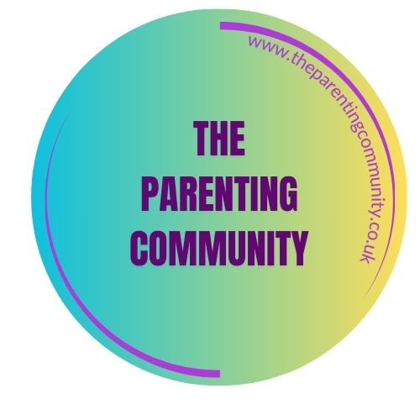

Copyright © 2025 – The Parenting Community Ltd. All Rights Reserved.

